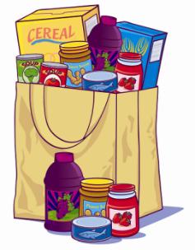
Cleobury Mortimer Food Bank
Emergency Food Parcel Referral

Date ……………………………………… Name ……………………………………………………………………………………………
Address …………………………………………………………………………………………………………………………………………….
………………………………………………………………………………………………………………………………………………………….
Age Range 16-25 …….. 26-45 ……….. 46-65 ………… over 65 ………….
Number of people in household ……………………………………………………..
Number of children in household ……………………………………………………
Nappies or baby food required? Yes …………………… No ………………… Details ………………………………….
Access to cooking equipment Yes ………………….. No ………………… Details ………………………………….
Are toiletries needed? Yes ………………….. No ………………… Details ………………………………….
Is pet food needed? Yes ………………….. No ………………… Details ………………………………….
Any dietary requirements? Yes ………………….. No ……………….. Details……………………………………

Is the current crisis caused by:
Benefit Problems
Health Problems
Financial Problems
Homelessness
Housing Problems
Other

Referred by (name and agency) ………………………………………………………………………………………………………...
……………………………………………………………………………………………………………………………………………………………

