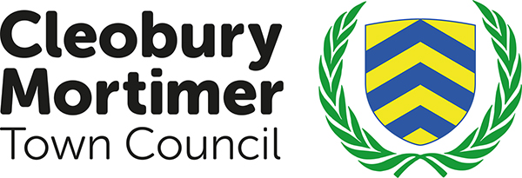

Policy Adopted: January 2018 Policy review date: December 2018
CLEOBURY MORTIMER TOWN COUNCIL
GRANT APPLICATION POLICY
The Council has a number of grant schemes designed to help voluntary and community organizations and, in some cases, individuals, to provide services and organize activities for local inhabitants. Generally, it will consider applications for grants which:
• Support its Purpose, Aims and Values
• Assist the council in delivering its corporate and service priorities;
• Support the residents of Cleobury Mortimer in improving their quality of life;
• Achieve more for the local community by working together; and
• Represent value for money.
Who Can Apply
Generally, the Council will consider applications from registered charities, other voluntary and community groups together with clubs and societies. Organizations need to demonstrate, as a minimum, a constitution or terms of reference and a system for recording income and expenditure – further details may be specified in the criteria for each scheme.
We particularly welcome joint applications from groups who feel they can achieve more by working together - collaboratively or in partnership with other projects or groups - for a specific project or activity.
We also welcome bids from new groups and the development and expansion of existing groups to meet identified needs.
Who Cannot Apply
Generally, the Council cannot accept applications from:
• Individuals unless they are seeking support for their own personal development in either a sporting or artistic activity.
• Private groups operating as a business for profit.
• Local groups whose fundraising is sent to their national headquarters for re-distribution.
• National and regional organizations unless they have a local base and/or where their application is for a specific project with people in the Parish.
• Political parties or organizations intending to support or oppose any particular political party, or to discriminate on the grounds of race, religion, disability, gender or sexual orientation.
Applications will not normally be considered if Central Government, the Health Authority or the County Council would be the most appropriate funder. However, if your bid cuts across services provided by both the Parish and one or more of these other public sector funders, and then we will consider your application.
If successful a report must be sent to the Town Council within six months explaining how the money was spent.

