Cleobury Mortimer Adult Outdoor Gym Equipment Survey
As part of a larger project we are applying for funding to have some adult outdoor gym equipment in the skate park. Please help us by taking a few minutes to fill in this survey. This will help towards knowing what you would like to see in the Skate Park area, and please if you have any other suggestions, let us know and return this either by email or hand in to the Library, address below.
Or join the group by letting the Town Council Clerk know.
Cardio Equipment
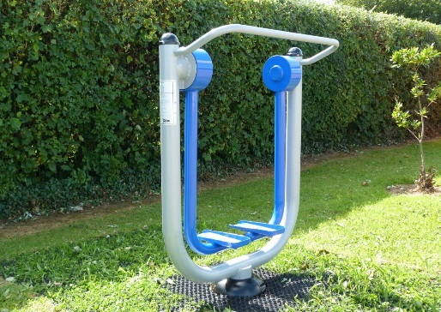
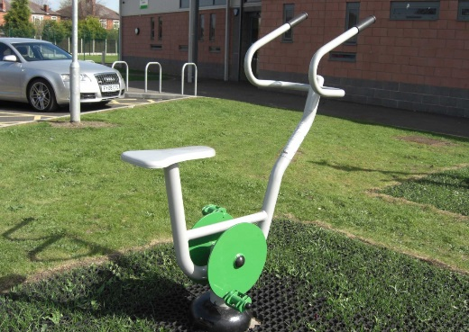
Outdoor gym equipment can include machines to support cardio-vascular fitness. If you would be interested in using cardio machines, please circle the four you would be most likely to use:
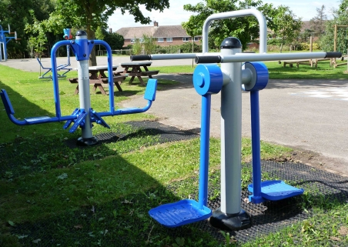
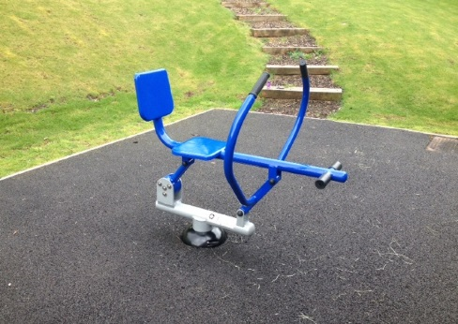
Skier Air Walker Cycle
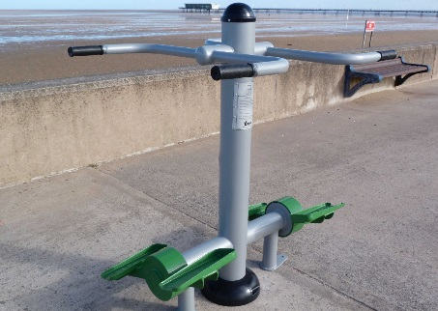
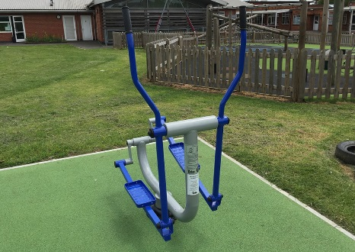
Cross trainer Stepper Rower
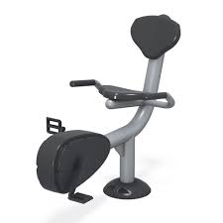
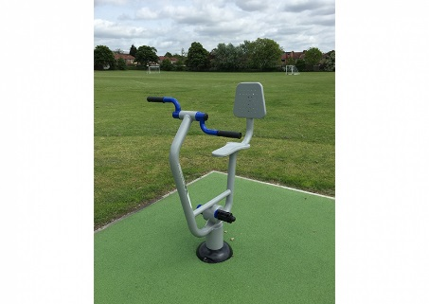
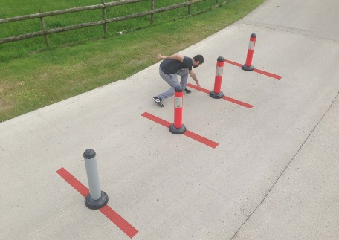

Shuttles Arm bike Recumbent Cycle

Strength Equipment
Outdoor gym equipment can also include strength training machines. If you are likely to use these, please circle the four that you would most like to see.
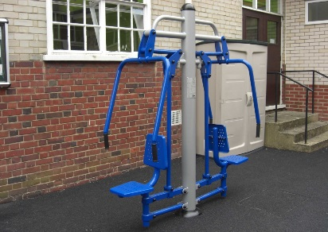
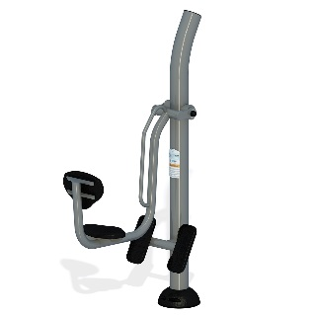
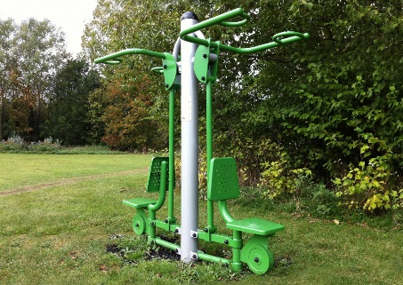

Leg press Lat pull Chest press
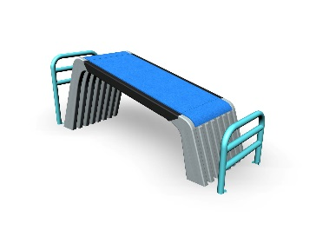
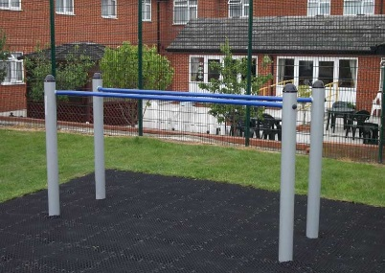
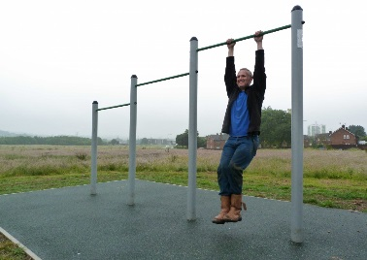

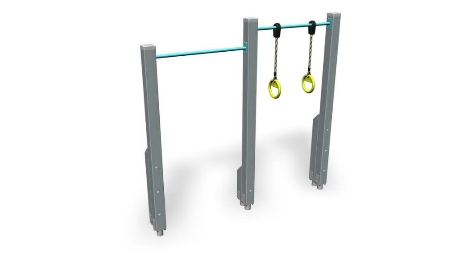
Chin up bars Sit up benches Parallel bars
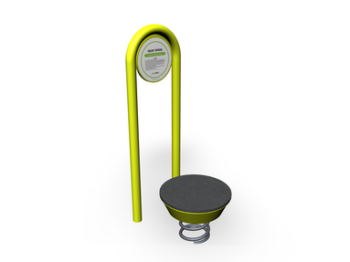
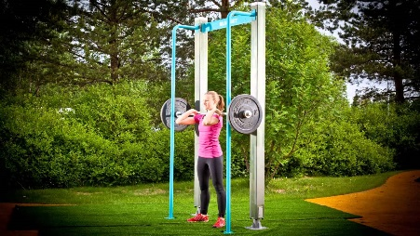
Squat spring Barbell Rings

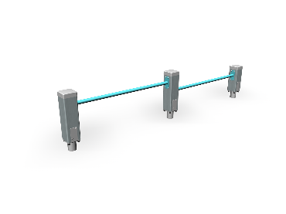
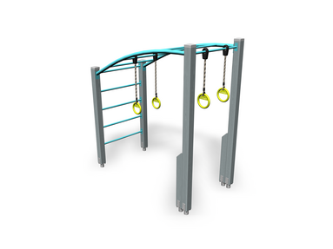

Monkey Bars Push up bars

Balance, flexibility and agility

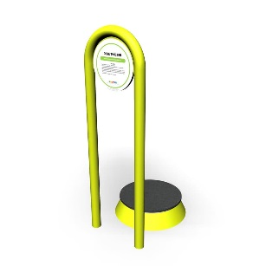
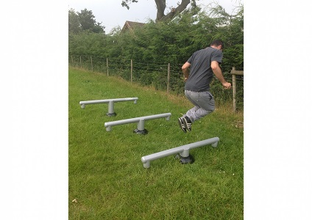
There are also other outdoor gym equipment options. Please circle up to four of the following you think you would use.

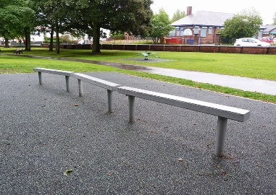

Balance beams Hurdles Core twister
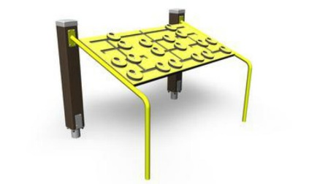
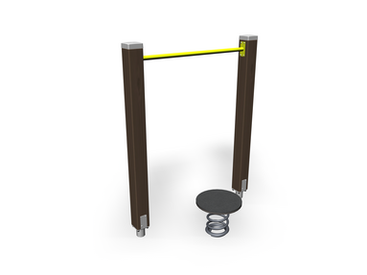
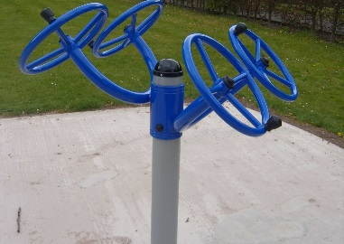

Tai chi wheels Balance Spring Memory Game
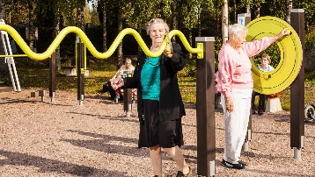
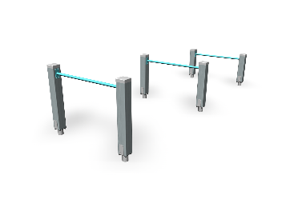

Multi purpose boxes Jumping bars Hand-eye co-ordination

Please help us further by taking a moment to answer the following questions. All responses will remain anonymous.

Are you:
Male Female

Age group:
16 – 25 26 – 35 36 -45 46 – 55 56-65 66+

When would you be most likely to use the outdoor gym equipment?
Before 9am
9 am – 12 noon
12 noon – 3pm
3pm – 6pm
After 6pm
Weekends only

How would you be most likely to use the outdoor gym equipment?
As an individual
With an informal group of friends
With a formal group (e.g. a fitness / running club)
With a personal trainer

What would be your main reason for using the outdoor gym equipment?
I prefer to exercise outdoors
To add variety to my workouts
It is less expensive than other forms of exercise
The opening hours of the indoor gym do not suit me
Other

Please add any other comments you have about what you would like to see included or how you would like to see the project develop:

Many thanks.
Cleobury Mortimer Town Council
Cleobury Country Centre
Love Lane
Cleobury Mortimer
DY14 8PE
01299 271154
Office hours: 9am to 4pm Monday to Thursday, 9am to 2pm Friday

